Dihedral Angle
Local Geometry: The geometry is captured mathematically by assigning to the ith atom a three-dimensional coordinate vector
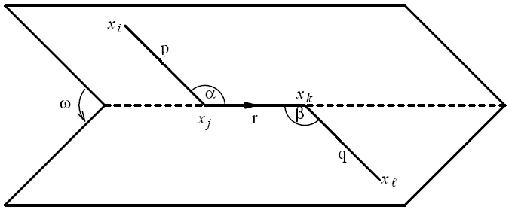
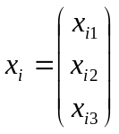
Fig. 1. Bond vectors, bond angles, and the dihedral angle.

Corresponding bond vectors:
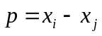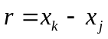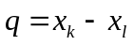
Corresponding bond length:
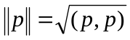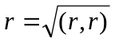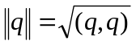
Definition:
dot product : 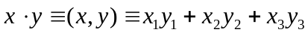
cross product: 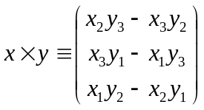
triple product: 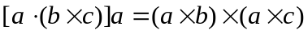
Bond angle 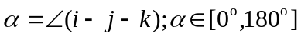:
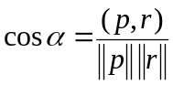 , 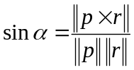

Bond angle 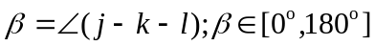:
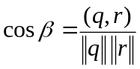 , 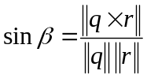
Dihedral angle 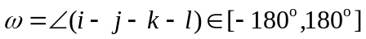(or the complementary torsion angle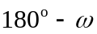)
It is defined as the angle between the normals through the planes determined by the atom i,j,k and j,k,l, respectively, and can be calculated from
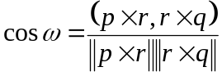, 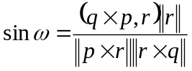
In particular, the sign of is given by that of the triple product 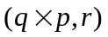

pseudo code

/************************************************************************/
/* double dihedralAngle ( double x_{i}, double y_{i}, double z_{i},
double x_{j}, double y_{j}, double z_{j},
double x_{k}, double y_{k}, double z_{k},
double x_{l}, double y_{l}, double z_{l})
---------------------------------------------------------
Input: double xi, yi, zi Input coordinates
xj, yj, zj
xk, yk, zk
xl, yl, zl
Returns: double The torsion angle between the 4 atoms
Calculates the torsion angle described by 4 sets of coordinates.
*/
double dihedralAngle(double xi, double yi, double zi, double xj, double yj, double zj,
double xk, double yk, double zk, double xl, double yl, double zl) {
double xij,yij,zij, xkj,ykj,zkj, xkl,ykl,zkl,
dxi,dyi,dzi, gxi,gyi,gzi,
bi,bk,ct,
z1,z2,ap,s,
/* Calculate the vectors p, r, q */
// p=x_{i}-x_{j} =[xij, yij, zij]^{T}
xij = xi - xj;
yij = yi - yj;
zij = zi - zj;
// r=x_{k}-x_{j} =[xkj, ykj, zkj]^{T}
xkj = xk - xj;
ykj = yk - yj;
zkj = zk - zj;
// q=x_{k}-x_{l} =[xkl, ykl, zkl]^{T}
xkl = xk - xl;
ykl = yk - yl;
zkl = zk - zl;

/* Calculate the normals to the two planes n1 and n2, this is given as the cross products:
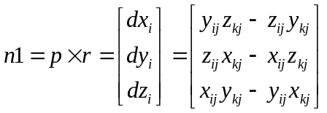,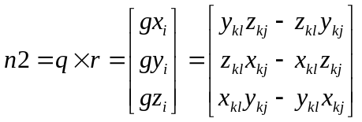
*/
dxi = yij * zkj - zij * ykj; /* Normal to plane 1*/
dyi = zij * xkj - xij * zkj;
dzi = xij * ykj - yij * xkj;

gxi = zkj * ykl - ykj * zkl; /* Mormal to plane 2*/
gyi = xkj * zkl - zkj * xkl;
gzi = ykj * xkl - xkj * ykl;

/* Calculate the length of the two normals */
bi = dxi * dxi + dyi * dyi + dzi * dzi; // bi = ||n1||²
bk = gxi * gxi + gyi * gyi + gzi * gzi; // bk = ||n2||²
ct = dxi * gxi + dyi * gyi + dzi * gzi; // 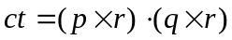
bi = (double)sqrt((double)bi); // 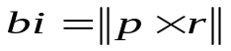
bk = (double)sqrt((double)bk); // 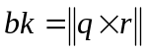
z1 = 1.0/bi;
z2 = 1.0/bk;
ct = ct * z1 * z2;
if (ct > 1.0) ct = 1.0;
if (ct < (-1.0)) ct = -1.0;
ap = acos(ct); // 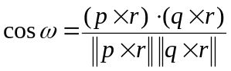
s = xkj * (dzi * gyi - dyi * gzi) + ykj * (dxi * gzi - dzi * gxi) + zkj * (dyi * gxi - dxi * gyi);
if (s < 0.0) ap = -ap;
ap = (ap > 0.0) ? PI-ap : -(PI+ap);
return(ap);
}

